**Initial Camera Setup**

**Setting the aperture and focus on the camera:**

1. Park the robot over the tote, so that the camera lenses is roughly 20.5inches above the tote edge. Turn on EOAT light by turning on DO[87] using the robot TP (I/O button > F1 Type > 3 Digital > F3 until it shows DO’s >scroll to DO 87 > toggle ON using F4)

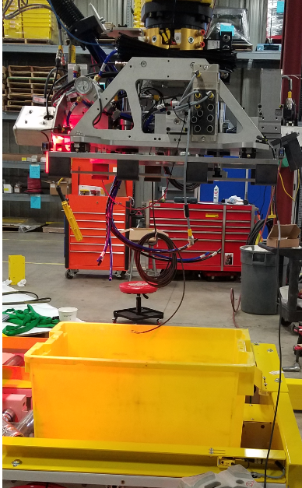

1. If iRVision software has not been installed, do that at this time
   1. Locate red usb stick inside robot controller, insert into usb drive of controller
   2. Connect to the robot via web browser (11.200.1.20)
   3. Click on “Vision Setup” tab
   4. Install when prompted in internet explorer
2. Using Internet Explorer, open Vision Setup and select SIDEA_CORNORLOATION program.

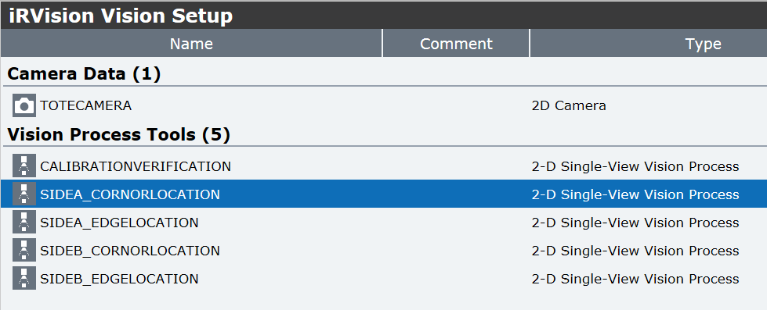

1. Select LIVE view, and adjust the focus and aperture on the camera until you get an image that resembles the picture below. Note: make sure the tote is in the same orientation as the image below

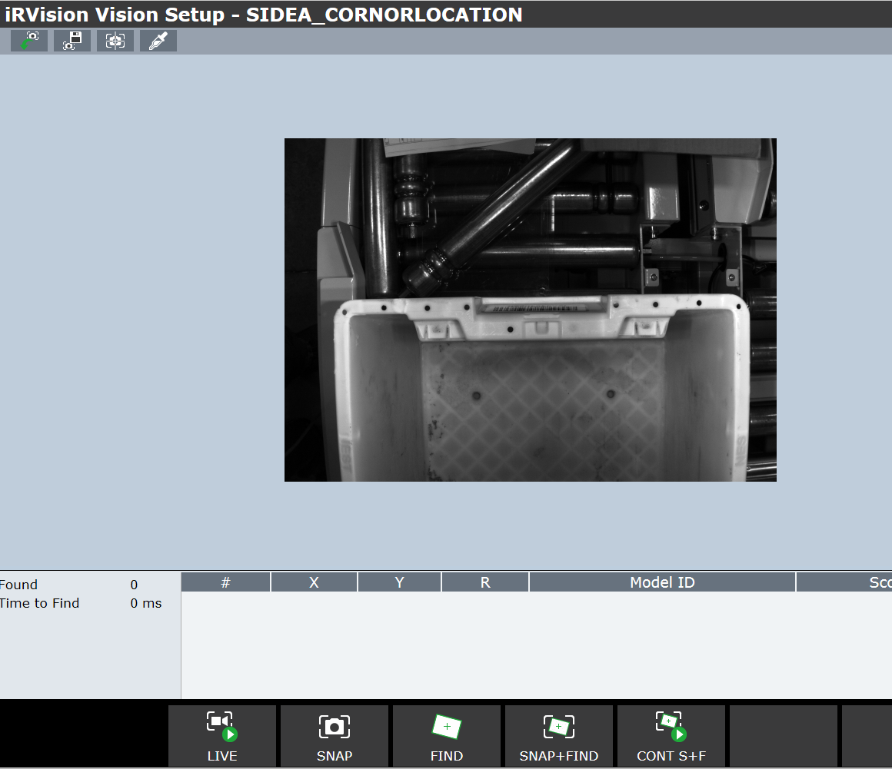

1. Stop the LIVE image, and press SNAP+FIND. If the camera is setup correctly, this tool should locate the corners of the tote, and outline them in GREEN. You will also see a score at the bottom of the screen.

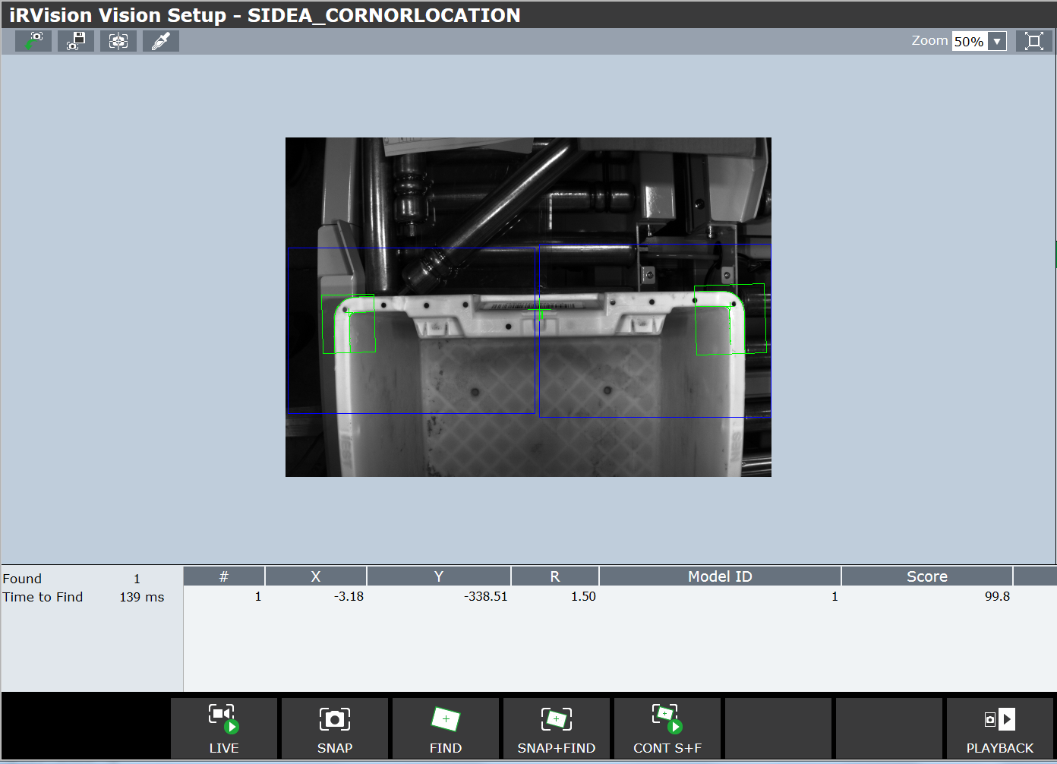

1. If the camera fails to find the corners, try adjusting the aperture or focus until you get a good image.